Post-Meeting Notes 24/06

Model Description + Planning

The model should be able to provide insight into the effect that AP/cytokines levels are having on the speed of healing, level of scarring, and risk of infection. At one extreme, we have excessive scarring but low chance of infection, at the other, low scarring but high chance of infection. Depending on the dynamics of model / data there will be most likely be a ‘most effective’ level of AP/anti-inflammation to use in burn treatment. Mark is focusing on expanding the HIIS model by adding new relevant cell types for now. Ben is focusing on a 2-dimensional ABM simulating the cell migration. The first version of our model will only look at AP → activated macrophages → TGFB distribution → Fibroblast/collagen deposit, using some metric to determine the risk of infection/level of scarring for each simulation.

Mark is focusing on this now:
At first, we will only create an abstract non-spatial interface with differential equations. The HIIS model will be expanded by adding cytokines and cell types related to the closure/contraction of the wound (cytokines: TGFB, PDGF, cell types: Fibroblasts, Collagen, Myofibroblasts) to fill the gap between the HIIS and TU delft contraction model. Differential equations will be built to model the relationship between the mentioned cytokines and cell types using these papers:

- Macrophage Dynamics in Diabetic Wound Healing - Helen V. Waugh, 2006

- Modeling the effects of treating diabetic wounds with engineered skin substitutes - Helen V. Waugh, PhD; Jonathan A. Sherratt, 2007

- Modelling the interaction of keratinocytes and fibroblasts during normal and abnormal wound healing processes, Shakti N. Menon, 2012

- Combining experimental and mathematical modeling to reveal mechanisms of macrophage dependent left ventricular remodeling, Yu-Fang Jin, 2011

The new implemented differential equations will look like:

TGFB
TGFB is secreted by activated macrophages which are implemented in the HIIS model (specifically M2 activated macrophages, but the HIIS model does not differentiate between M1 and M2). TGFB is also involved in a complex feedback regulation loop with fibroblasts. TGFB activates fibroblast and stimulates the fibroblasts to produce collagen, while fibroblasts also regulate the TGFB secretion levels. The differential equation for TGFB will be:

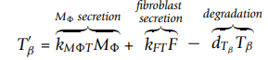

Variable | Description | Value | Reference
kMФT | Macrophage TGF-b production rate | 0.07 pg/cell/day | Huang M, Sharma S, Zhu L, Keane M, Luo J, Zhang L, Burdick M, Lin Y, Dohadwala M, Gardner B, et al: IL-7 inhibits fibroblast TGF-beta production and signaling in pulmonary fibrosis. J Clin Invest 2002, 109:931-937.
MФ | Macrophage concentration
kFT | Fibroblast TGF-b production rate | 0.004 pg/cell/day | Cobbold CA, Sherratt JA: Mathematical Modelling of Nitric Oxide Activity  in Wound Healing can explain Keloid and Hypertrophic Scarring. Journal  of Theoretical Biology 2000, 204:257-288
F | Fibroblast concentration
dTB | TGFB decay rate | 15 day-1 | Zhang H, Ahmad M, Gronowicz G: Effects of transforming growth factorbeta 1 (TGF-[beta]1) on in vitro mineralization of human osteoblasts on implant materials. Biomaterials 2003, 24:2013-2020.

Fibroblasts:
Fibroblast are attracted to the wound site by TGFB. A function determining the attraction of fibroblast based on the levels of TGFB will calculate the proliferation rate of the fibroblasts (retrieved from reference 4). The crowding effect by fibroblasts, macrophages, and collagen in the myocardium, which is affected by their total environment density, is also implemented in the fibroblast proliferation function. The crowding effect was considered by calculating the normalized density with respect to their maximum density in scar tissue (reference 4). The formula for the fibroblast concentration will be:

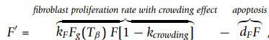

Variable | Description | Value | Reference
KF | Fibroblast growth rate | 0.924 day-1 | Johan D, Heilborn KBAH: Inhibited proliferation of fibroblasts derived from chronic diabetic wounds and normal dermal fibroblasts treated with high glucose is associated with increased formation of L-lactate. Wound Repair and Regeneration 1998, 6:135-141.
Fg(TB) | Influence of TGFB on fibroblast growth |  | Reference 4
F | Fibroblast concentration
DF | Fibroblasts decay rate | 0.12 day-1 | Darby IA, Bisucci T, Hewitson TD, MacLellan DG: Apoptosis is increased in a model of diabetes-impaired wound healing in genetically diabetic mice. The International Journal of Biochemistry & Cell Biology 1997, 29:191-200

Crowding effect function:
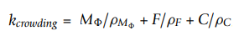

Collagen:
Collagen is secreted and attracted to the wound area by fibroblasts. The growth rate is multiplied by a function determining the secretion of collagen by fibroblast based on the levels of TGFB and by a function determining the secretion of collagen based on the already present level of collagen (reference 4). The collagen forms the ECM of the new skin.
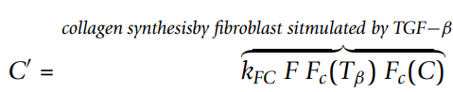

Variable | Description | Value | Reference
KFC | Fibroblast collagen production | 20 μg/cell/day | Ignotz R, Massague J: Transforming growth factor-beta stimulates the expression of fibronectin and collagen and their incorporation into the extracellular matrix. J Biol Chem 1986, 261:4337-4345

Future plans:
Later PDGF and maybe myofibroblasts will be implemented. PDGF is secreted by fibroblasts and macrophages:

Description | Value
Macrophage PDGF production rate | 0.015 pg/cells/day | Badgett A, Bonner JC, Brody AR. Interferon-gammamodulates lung macrophage production of PDGF-BB andfibroblast growth.J Lipid Mediators Cell Signal1996; 13:89–97.
Fibroblast PDGF production rate | 0.0015 pg/cells/day | Baker EA, El-Gaddal S, Aitken DG, Leaper DJ. Growthfactor profiles in intraperitoneal drainage fluid followingcolorectal surgery: relationship to wound healing and sur-gery.Wound Repair Regen2003; 11: 261–7.

Could not find specific for fibroblast – myofibroblast conversion yet.

After implementing the new cell types, the model can be validated using data from Paul.

The expanded EBM model can serve as a setup for the TU Delft contraction model, providing the model with initial setups based on calculated fibroblast/myofibroblasts/collagen.

Example of expanded results:

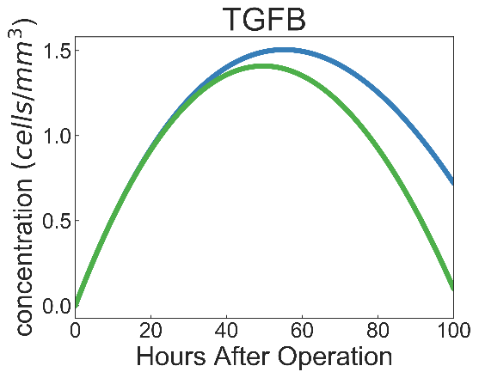
Major issues for now:
HIIS has no new influx of resting macrophages/Neutrophils. The model starts with a certain number of resting neutrophils, and no new resting neutrophils are delivered. In wound healing, new immune cells are constantly recruited to the wound area over time and collagen production. An influx of new immune cells should be added to the model to make this work.

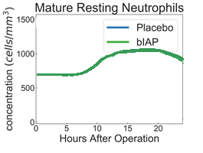
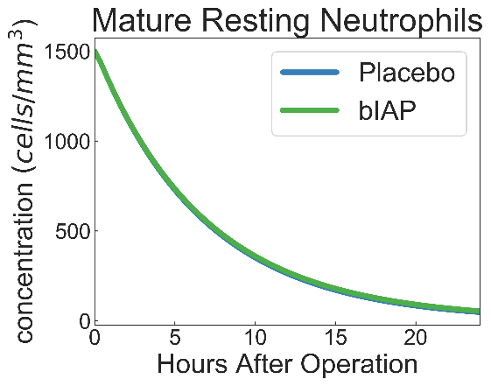

Ben is focusing on this now:

Two-Dimensional ABM with 2 areas, the first, at the edge of the wound where the cytokines in this area are input into the HIIS model (at first it will be initialized with values of the initially included cell types from the HIIS model (after mark is finished the fibroblasts, etc. can be included.), depending on level of AP, and not updated). Cell-Agents then migrate around the model (some affected by attractant gradients), having interactions.

TGFB (the first cytokine to be added) attractant gradients are the most relevant, fibroblasts move (and deposit) according to them. Since we have data on the amount of TGFB activated macrophages secrete, we can quite easily approximate the amount of TGFB in the wound and thus will be the first cytokine we focus on.

Mark’s abstract interface is the zone of blood exposure in the ABM, early experiments can ascertain the effect of different AP levels on the cytokine composition and subsequent healing. The cytokines in this tissue compartment will migrate across the wound, see paper (Weavers et al., 2016). Depending on the success of this implementation, we will then attempt to pass information from this zone to the HIIS model at certain timesteps. The model can also be extended to include the use of topical treatments such as anti-TGFB or Cerium Nitrate. Cytokines could also be allowed to move in/out of both zones, representing composition in surrounding skin (“hair follicles serve as reservoirs of skin mast cell precursors” - stem cell modulation is also being explored as a potential therapy).

Future extension: Hair follicles

Zone of Blood Exposure
Zone of No-Blood Exposure

In the future, these zones may be governed by reaction-diffusion equations, or extended for greater granularity

Cytokines / Fibroblasts / Macrophages

The zone of no-blood exposure can also be seen as an area of unresolved inflammation and therefore should also be causing some level of inflammatory cytokine production/triggering. Each cell, should also have a variable describing its oxygen content (e.g. macrophages stimulated by low O2 to induce angiogenesis). Can be extended to show cell death (by ischemia) at a threshold. The first version of our model will only look at AP → activated macrophages → TGFB distribution → Fibroblast/collagen deposit, using some metric to determine the risk of infection/level of scarring for each simulation.
Both:

Angiogenesis
Angiogenesis will not be explicitly modeled. However, one only has to include pro-angiogenic factors to approximately model this, this governs the movement of the blood / no-blood exposure demarcation. As the model becomes more refined, blood flow/angiogenesis can be simulated with greater accuracy, either by looking at pro and anti-angiogenic factors that are part of the innate immune system or having further differentiated zones, or with reaction-diffusion equations. For now, angiogenesis will be simulated by adjusting the vascular permeability of areas,.

AP also has a large effect on barrier integrity, clearly it would have an impact on migration speeds yet we have not considered this. Cell migration and barrier integrity would therefore be a good candidate for model extension (and very novel).

Too much AP | ‘Godilocks’ AP | Too little AP
Little to No Scarring |  | Excessive Scarring
High Risk of Infection |  | Low Risk of Infection

Risk of infection
To ascertain the risk of infection, we will have to create a metric that includes factors as neutrophil count or neutrophil-bacteria ratio (mentioned in previous document, see /bacterial infection/bacterial infections when suppressing inflammation.docx).

Level of Scarring

Excessive scarring could be seen as large dumps of collagen/fibroblasts, however, in the future would be nicer to test if the fibroblasts are laid down in “healthy” basket-weave orientation.

Future Cytokine Inclusion (see new_papers_after_meeting/cells_and_roles.pdf)

TNFa (pro-inflammatory) is also secreted by activated macrophages and TNFa suppression may also be used to slow down healing and reduce scarring. Higher concentrations of TNFa increase the fibroblast proliferation rate. It is increased in chronic wounds due to TNFa causing elevated metalloproteinases that degrade the local ECM and thus impair cell migration (Tarnuzzer and Schultz, 1996). It has also been used to stimulate angiogenesis, which makes it an attractive cytokine to model since we can extend design to include approximate angiogenesis dynamics, in the future.

TGFa (also secreted by activated macrophages) is a chemoattractant for keratinocytes (part of the reepithelisation process; epidermal keratinocytes can contribute to de novo hair follicle formation during large wound healing).

Interleukins 10 and 6.
6 – IL6 is produced by both macrophages and fibroblasts, while it attracts neutrophils. This direct connection to other elements of our ABM make it a very relevant cytokine to include, due to its action in the inflammation stage. Furthermore, it stimulates collagen synthesis in fibroblasts so is also active in the proliferation stage.
10 - Secreted by macrophages. It inhibits the activation of neutrophils and macrophages, ihibits expression of TNF-a in neutrophils, macrophages, and fibroblasts. Inhibits expression of IL-6 in macrophages and fibroblasts. Further, it stimulates expression of TGF-b in macrophages and fibroblasts, stimulates IL-10 in macrophages, and inhibits activated neutrophils (survival).

Model Details

3nm cells ??? - average diameter of protein, average width of cellular membrane, average velocity of a macrocolecule in a cell is approximately 3 nm per ms

Macrophage class
- activated vs resting
- phenotype

Neutrophil class
- Resting vs activated vs apoptotic vs necrotic

TGFB class

Fibroblast class

